SPRINT 2

|  |  |
| --- | --- |
| TEAM ID | PNT2022TMID50061 |
| PROJECT NAME | Real-Time River water Quality Monitoring and  Control System |

LOGIN PAGE:

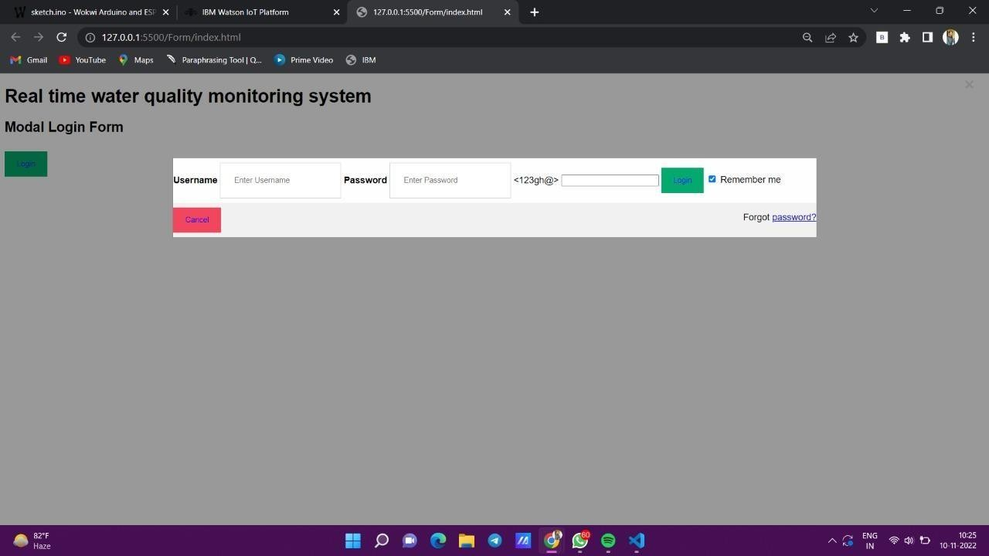

CODE:

<!DOCTYPE html>

<html>

<head>

<h1> Real time water quality monitoring system</h1>

<metaname="viewport" content="width=device-width, initial-scale=1">

<style>

body {font-family: Arial,Impact, 'Arial Narrow Bold', sans-serif, sans- serif;}

/* Full-width input fields */ input[type=text], input[type=password] { width: 150;

padding: 23px 24px; margin: 8px 0; display: inline-block; border: 1px solid #ccc;

box-sizing: border-box;

}

/* Set a style for all buttons */ button {

background-color: #04AA6D; color:blue;

padding: 15px 21px; margin: 8px 0;

border: none; cursor: pointer; width: 102;

}

button:hover { opacity: 0.7;

}

/* Extra styles for the cancel button */

.cancelbtn {

width: min-content padding: 10px 18px; background-color: #f4455f

}

/* Center the image and position the close button */

.imgcontainer { } text-align: right: ;;

margin : 24px 0 12px 0; position: relative

}

img {water quality monitoring system} width: 56;

border-radius: 50%;

}

.container { padding: 16px;

}

span.psw { float: right;

padding-top: 16px;

}

/* The Modal (background) */

.modal {

display: none; /* Hidden by default */ position: fixed; /* Stay in place */

z-index: 1; /* Sit on bottom*/

left: 0;

top: 0;

width: 100%; /* full width */ height: 100%; /* medium height */

overflow: auto; /* Enable scroll if needed */ background-color: ybg(0,0,0); /* Fallback color */

background-color: rgba(0,0,0,0.4); /* Black w/ transprenant */ padding-top: 60px;

}

/* Modal Content/Box */

.modal-content { background-color: #fefefe;

margin: 5% auto 15% auto; /* 5% from the top, 15% from the bottom and centered */

border: 1px solid #888;

width: 65%; /* Could be more or less, depending on screen size */

}

/* The Close Button (x) */

.close {